TITLE: Complete User Guide – The Healer Network
Version: v1.0
Date: 1/22/2026

1. Introduction
The Healer Network is an online platform that connects users with professional healers for guidance, therapy, and wellness sessions. The platform allows users to easily find a healer, book and appointment, make a secure payment, and attend sessions online through Google Meet — all in one place also onsite.
Users can browse healer profiles, view their expertise, and choose a suitable time for an appointment. Once an appointment is booked and payment is completed, the session is conducted online via Google Meet, making it convenient and accessible from anywhere.
Healers can manage their availability, accept appointments, and provide personalized healing sessions in a professional and secure environment.
The Healer Network ensures:
Simple and smooth appointment booking
Secure online payment system
Private and reliable Google Meet sessions
Easy communication between users and healers
This platform is designed to create a trusted digital space where healing, guidance, and wellness services are accessible to everyone

2. Getting Started
To begin using The Healer Network, follow the steps below:
Open your web browser and search on Google for
http://thehealernetwork.com/
or directly enter the website URL in the address bar.
When the website opens, you will see the home page.
Take some time to read the content and learn about the platform, including:
What The Healer Network Offers?
How users and healers connect
How online and onsite appointments work
Once you understand the flow of the website and how the platform works, locate the “Sign Up” button on the website.
Click the Sign Up button to create a new account.
Fill in the required details and register yourself as a user.
After successful registration, you can log in and start booking appointments with healers.

User Guide:
To register as a new user on The Healer Network, follow these steps:
Click the Sign Up button on the website.
The registration form will appear on the screen.
Enter the required information:
Full Name
Email Address
Password
After filling in the details, click the Register button.
A verification email will be sent to your registered email address.
Open your email inbox and find the verification email from The Healer Network.
Click the Verify Email link to confirm your account.
Once your email is verified, your account will be activated, and you can log in and start using the platform.

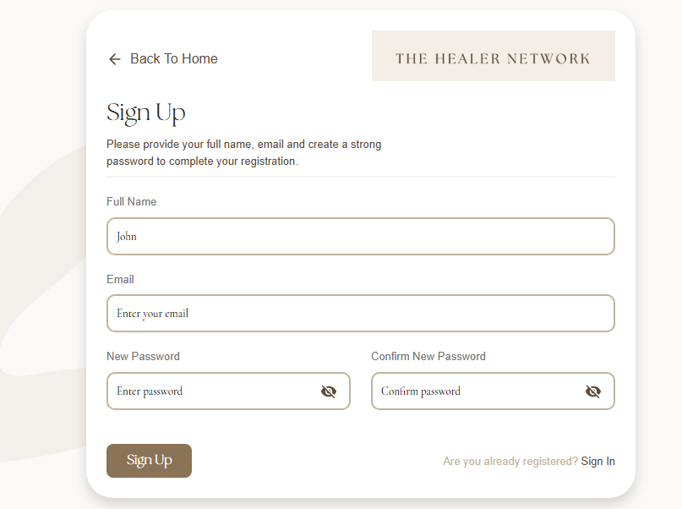

User Dashboard (After Login)
After successfully logging in, the user is redirected to the Dashboard. This page allows users to manage their appointments, profile, and account settings easily.

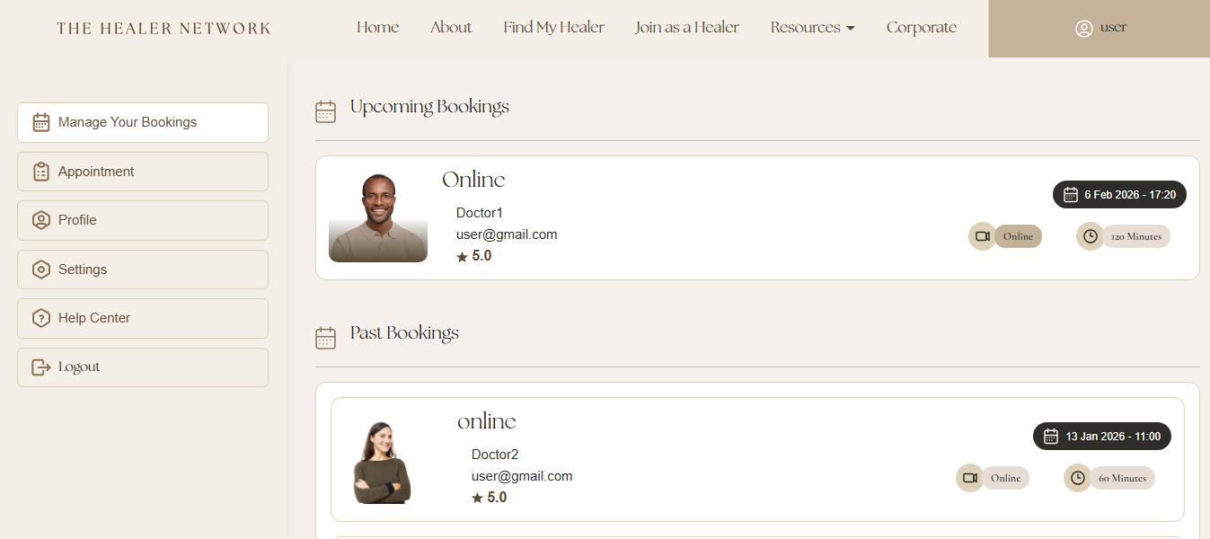
How to make appointment:
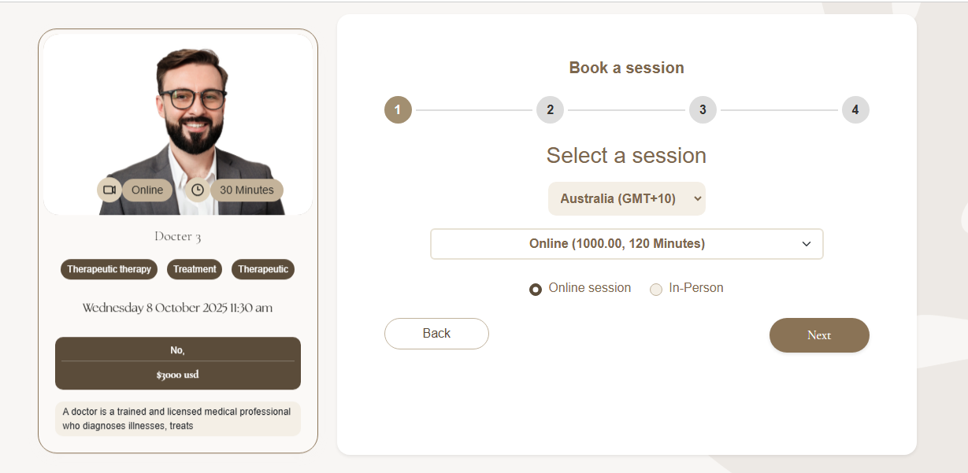

Select Session and price Next
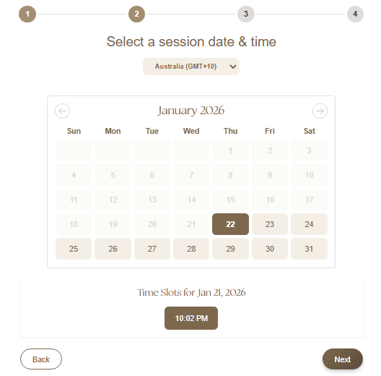
Select the date and time and Next
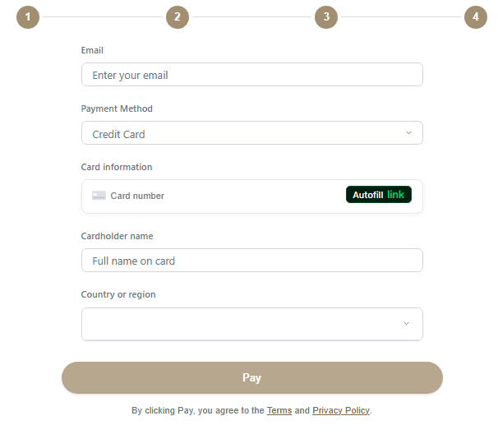
Payment and Confirmation Process
After selecting a healer and appointment time, the user must complete the payment to confirm the booking.

Rating Appointment:
When complete Appointment to Give rating

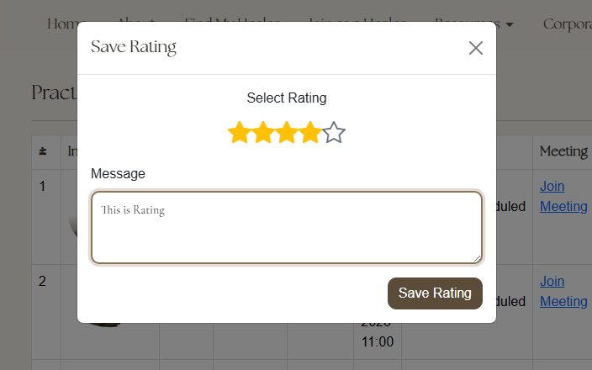

Change or Cancel an Appointment
Users can easily reschedule (change date and time) or cancel an appointment from their appointment.
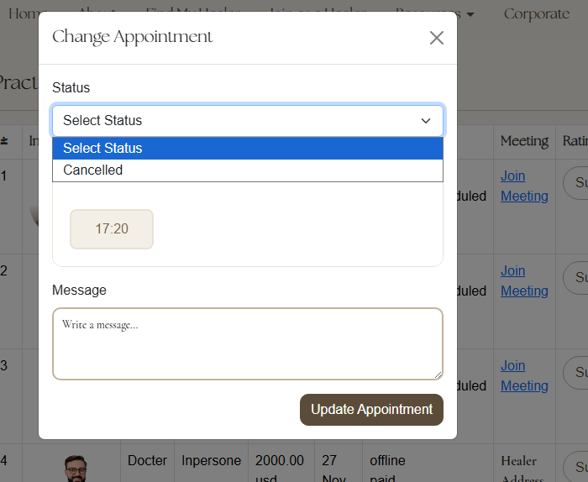

Healer Guide
How to Register as a Healer
To join The Healer Network as a healer, follow the steps below:

Step 1: Open the Website
Open your web browser.
Go to http://thehealernetwork.com/.

Step 2: Click “Join as a Healer”
On the top navigation bar (Navbar), find the option “Join as a Healer”.
Click on “Join as a Healer”.

Step 3: Click “Apply Now”
After clicking “Join as a Healer”, you will be redirected to the healer information page.
Read the details about becoming a healer on the platform.
Click the “Apply Now” button to start the registration process.



Step 4: Complete the Healer Application Form
Fill in the required information, such as:
Full Name
Email Address
Professional Details
Areas of Expertise
Ensure all information is accurate and complete.
Submit the application form.

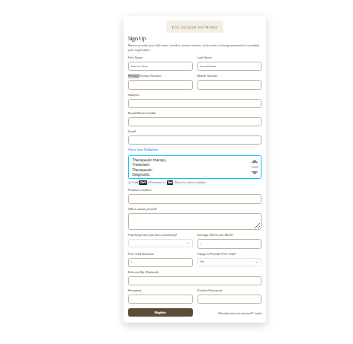

Step 5: Email Confirmation & Approval
After submitting the application, you will receive a confirmation email.
The Healer Network team will review your application.
Once approved, you will receive an approval email with further instructions to access your healer dashboard

Healer Dashboard – Bookings & Availability Management
After logging in as a Healer, you are redirected to the Healer Dashboard. This dashboard allows you to manage patient bookings, appointments, services, availability, and account settings and update Profile.

User Appointment Dashboard
See upcoming and past appointments with users.

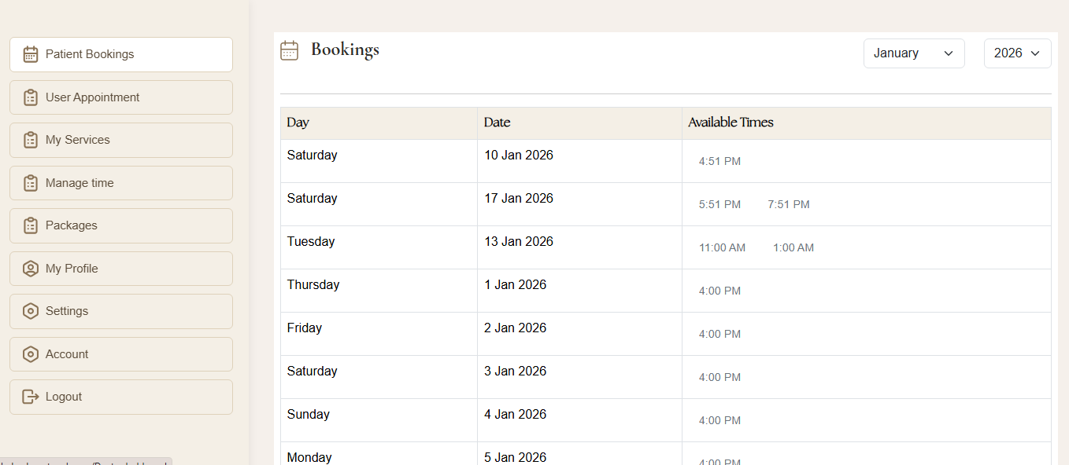
Patient Bookings
View all bookings made by users for your services.
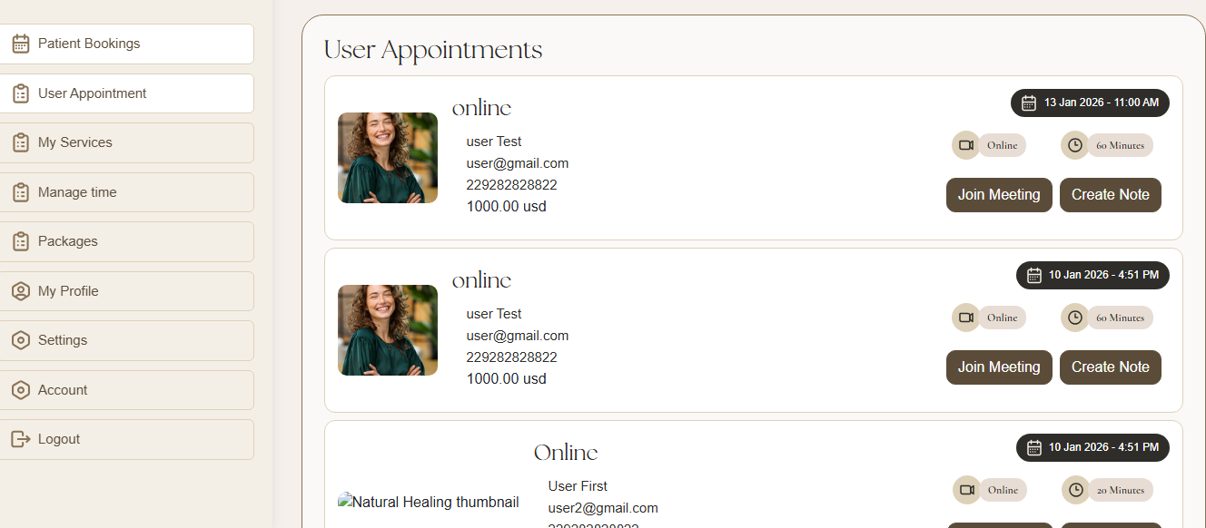

My Services
Create and manage the healing services you offer.
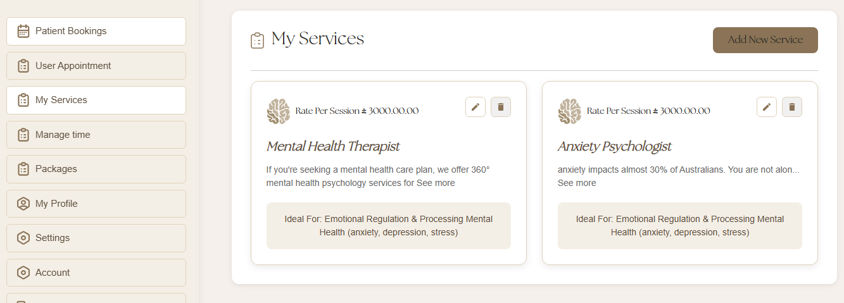

Manage Time
Set your availability dates and time slots for bookings.
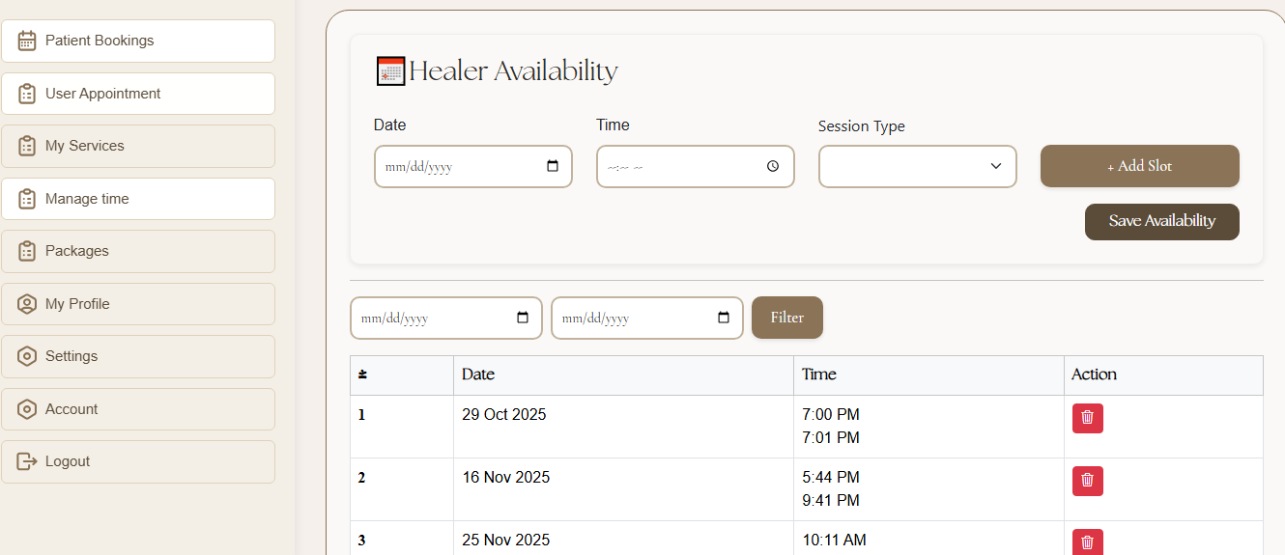

Packages
Create service packages for users.
Healer add here package time price online or onsite
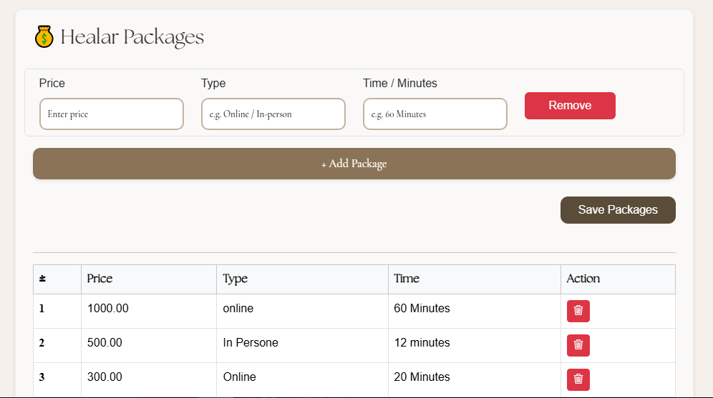
My Profile
View and update your personal and professional details.The Healer profile update page and add certificate here
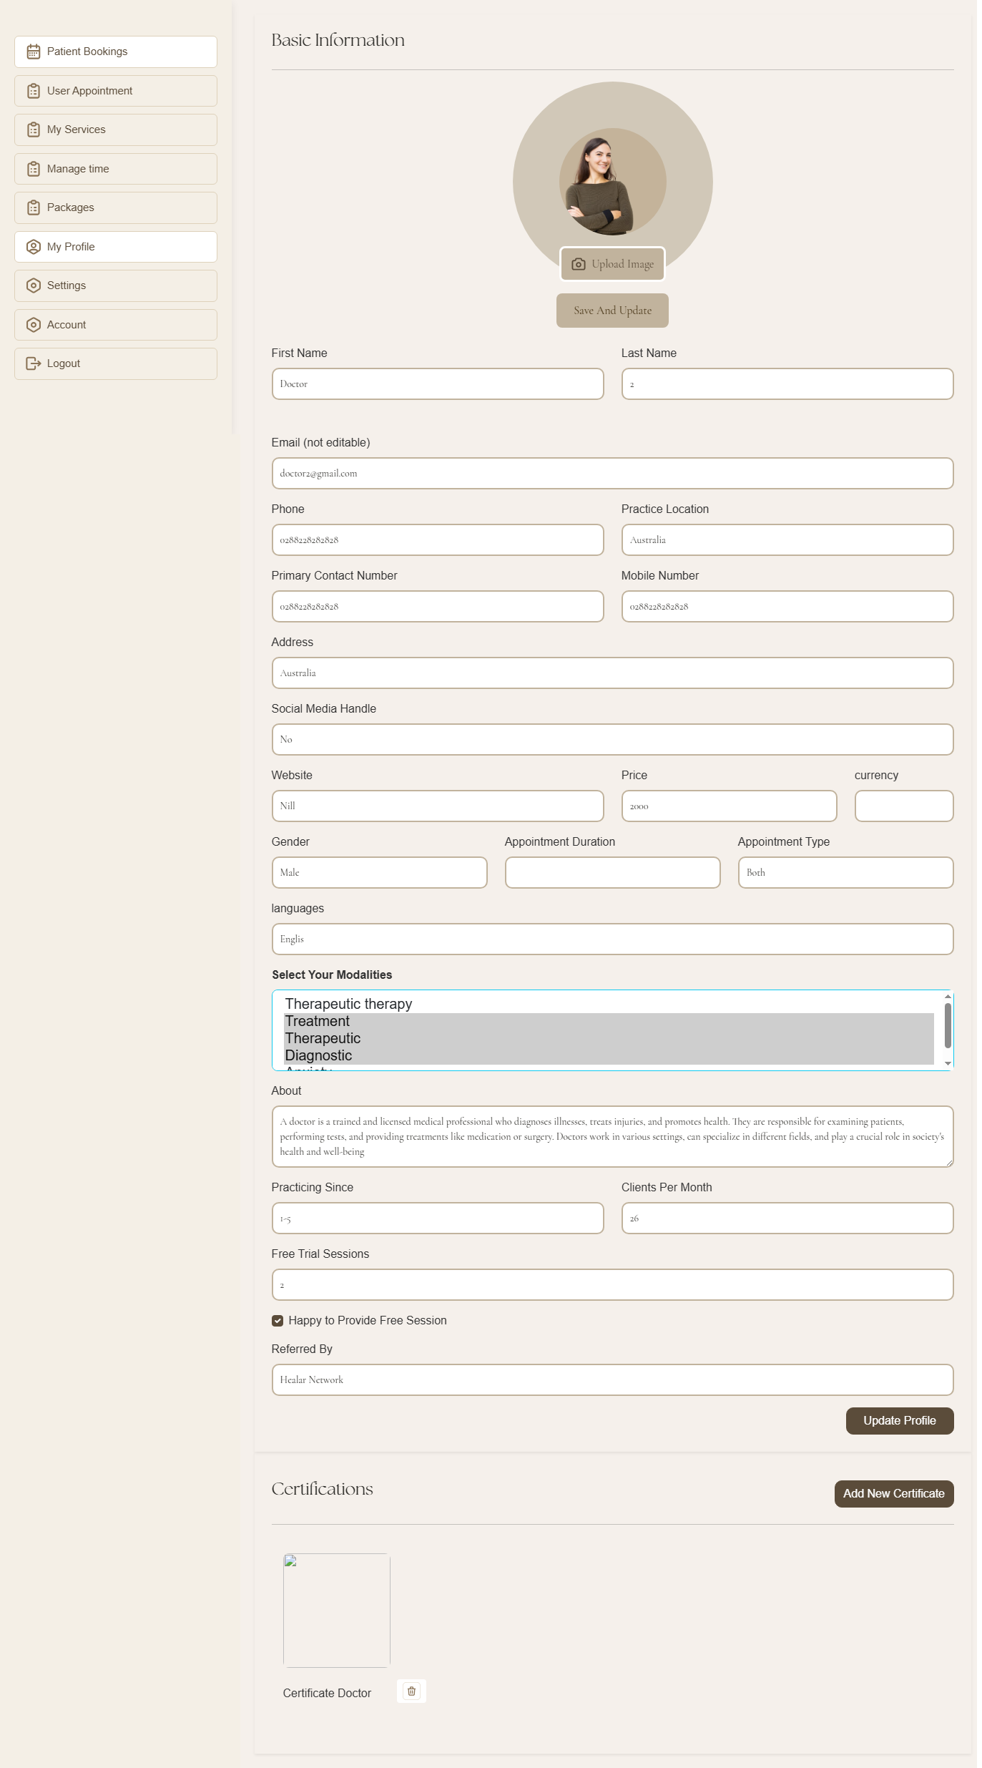

Settings
Manage password setting and update.
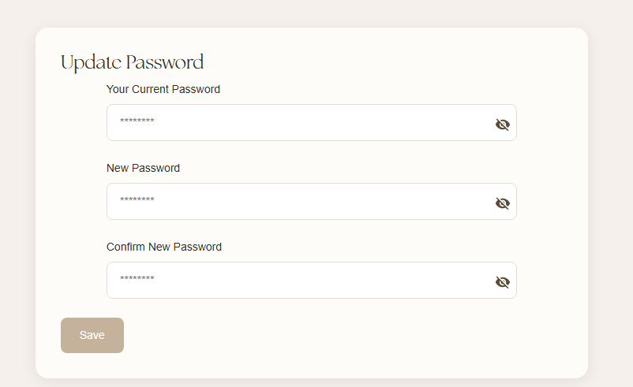
Account
View account-related information.
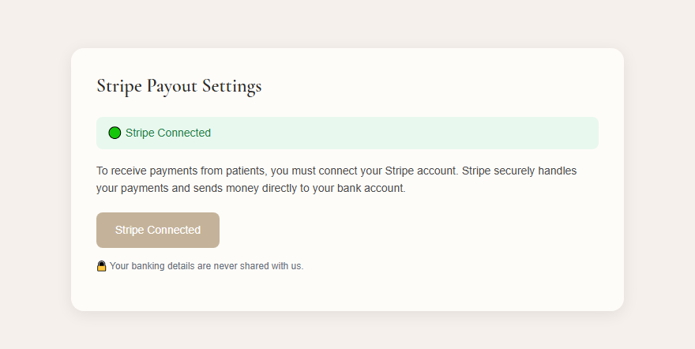
Logout
Securely log out of your healer account.

Contact & Support
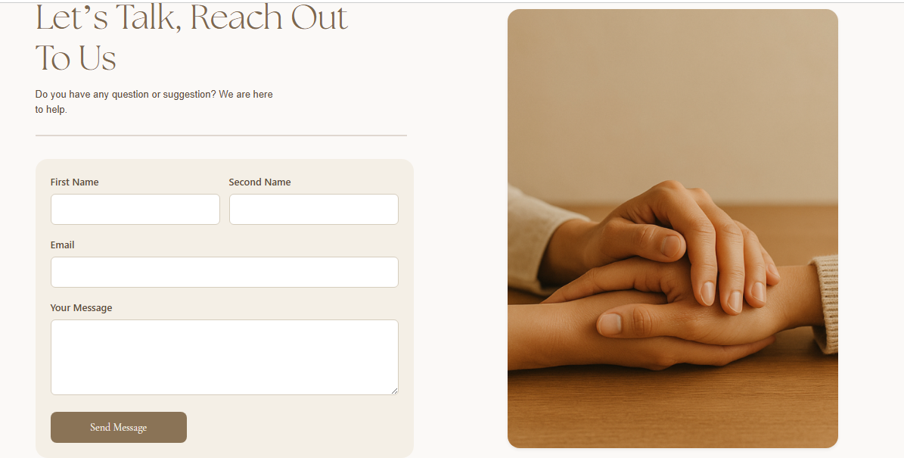

How to Search for a Healer
Users can easily find a suitable healer using the Find a Healer feature and advanced filters.
Step 1: Click “Find a Healer” from the Navbar
- Open The Healer Network website.
- On the top navigation bar (Navbar), click “Find My Healer” or “Find a Healer”.
- You will be redirected to the healer search page.

Step 2: Use the Search Bar
At the top of the page, you will see the search section:
- What support are you looking for?
Enter the type of help or service you need.
- Location
Select Anywhere / Online or use My Current Location.
- Click the Submit button to view available healers.

Step 3: Open Filters
- Click the Filters button.
- Multiple filter options will appear to help refine your search.

Step 4: Apply Filters to Find the Right Healer
You can filter healers using the following options:
- Type of Support (Therapy, Treatment, Anxiety, etc.)
- Location
- Duration (Session length)
- Gender
- Price
- Currency Type
- Language
- Accessibility
- Certifications
- Rating
Select the options that match your preferences.

Step 5: Apply or Clear Filters
- Click Apply Filters to view healers that match your criteria.
- Click Clear to remove all selected filters and start a new search.

Step 6: Browse by Categories
Below the filters, you can also browse healers by categories such as:
- Therapeutic Therapy
- Treatment
- Diagnostic
- Anxiety
- View All
Click any category to quickly see relevant healers.

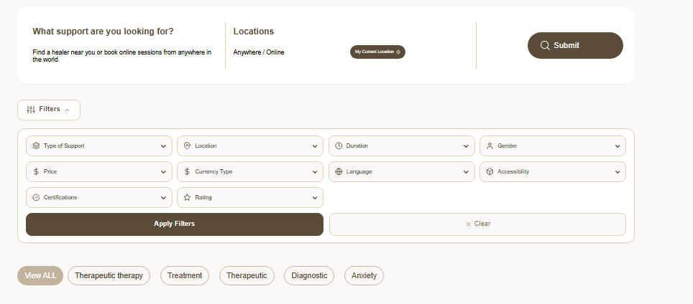

Also subscribe
Subscribe to our newsletter to receive monthly updates of upcoming events, newly added holistic healers and top tips to enhance your wellbeing.

